PORTFOLIO PROJECT
Submitted by
{NANDHA KUMAR M}
Reg.No : 1P21MC033
In partial fulfilment of the requirement for the award of the Degree of
Master of Computer Applications
Bharathiar University
Coimbatore.
Under the Internal Supervision of
Dr. S Ranjitha Kumari M.sc.,M.Phil.,Ph.D
Associate Professor
School of Computer Studies-MCA

Master of Computer Applications,
Rathnavel Subramaniam College of Arts and Science (Autonomous),
Sulur, Coimbatore – 641 402
February 2022

RATHNAVEL SUBRAMANIAM COLLEGE OF ARTS AND SCIENCE
(AUTONOMOUS)
AFFLIATED TO BHARATHIAR UNIVERSITY
NAAC Re-accredited & ISO 9000:2008 Certified
SULUR, COIMBATORE-641402.
February 2022
Register Number – {1P21MC033}

Certified bona fide original record of work done by {Nandhakumar M}

Internal Supervisor HOD

Submitted for the project Evaluation and Viva voice held on………………….
Internal Examiner External Examiner

CHAPTER
NAVIGATION SECTION:

Index.html:

<body>

<!-- header section starts -->

<header>

<div class="user">
<img src="/images/Snapchat-156730314.jpg" alt="">
<h3 class="name">Nandha Kumar</h3>
<p class="post">front end developer</p>
</div>

<nav class="navbar">
<ul>
<li><a href="#home">home</a></li>
<li><a href="#about">about</a></li>
<li><a href="#education">education</a></li>
<li><a href="#project">Project</a></li>
<li><a href="#contact">contact</a></li>
</ul>
</nav>

</header>

<div id="menu" class="fas fa-bars"></div>

Style.css:
body{
background:#111;
overflow-x: hidden;
padding-left: 35rem;
}

section{
min-height: 100vh;
padding:1rem;
}

.btn{
padding:.6rem 2rem;
background:#333;
color:#fff;
cursor: pointer;
margin-top: 1rem;
font-size: 2rem;
border-radius: 5rem;
}

.btn i{
padding:0 .5rem;
font-size: 1.8rem;
}

.btn:hover{
background:var(--yellow);
}

.heading{
text-align: center;
margin:0 6rem;
font-size: 4rem;
padding:1rem;
border-bottom: .1rem solid #fff4;
color:#fff;
}

.heading span{
color:var(--yellow);
}

header{
position: fixed;
top:0; left:0;
z-index: 1000;
height:100%;
width:35rem;
background:#1a1a1a;
display: flex;
align-items: center;
justify-content: center;
flex-flow: column;
text-align: center;
}

header .user img{
height:20rem;
width:20rem;
border-radius: 20%;
object-fit:cover;
margin-bottom: 1rem;
border:2rem solid var(--yellow);
}

header .user .name{
font-size: 3.5rem;
color:#fff;
}

header .user .post{
font-size: 2rem;
color:#eee;
}

header .navbar{
width:100%;
}

header .navbar ul{
list-style: none;
padding:1.5rem 3rem;
}

header .navbar ul li a{
display: block;
padding:1rem;
margin:1rem 0;
background:#333;
color:#fff;
font-size: 2rem;
border-radius: 3rem;
}

header .navbar ul li a:hover{
background:var(--yellow);
}

#menu{
position: fixed;
top:2rem; right:2rem;
background:#333;
color:#fff;
cursor: pointer;
font-size: 2.5rem;
padding:1rem 1.5rem;
z-index: 1000;
display: none;
}

HOME SECTION:
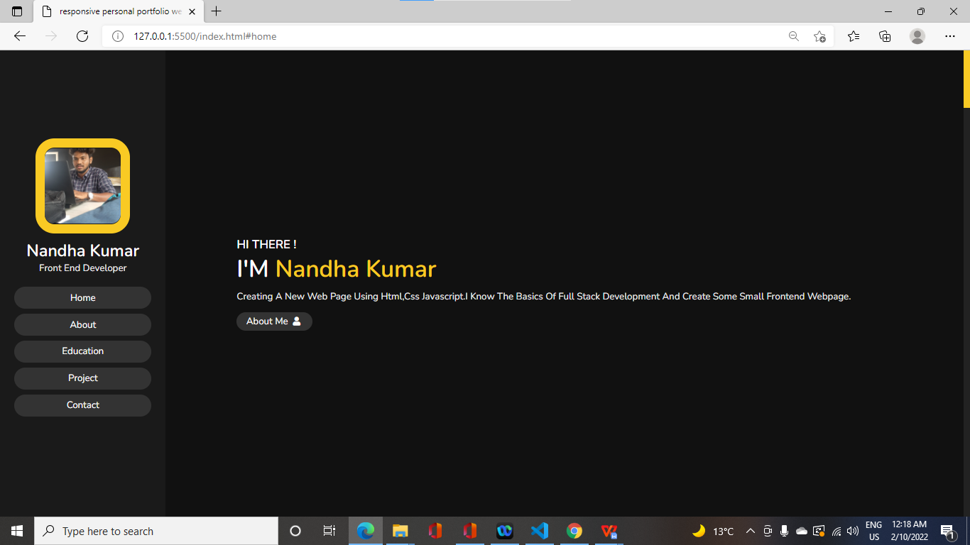
Index.html:
<section class="home" id="home">

<h3>HI THERE !</h3>
<h1>I'M <span>Nandha Kumar</span></h1>
<p>Creating a new web page using html,css javascript.I know the basics of full stack development and create some small frontend webpage.
</p>
<a href="#about"><button class="btn">about me <i class="fas fa-user"></i></button></a>

</section>

Style.css:
.home{
display: flex;
justify-content: center;
flex-flow: column;
padding:0 15rem;

}

.home h3{

font-size: 2.5rem;
color:#fff;
}

.home h1{
font-size:5rem;
color:#fff;
}

.home h1 span{
color:var(--yellow);
}

.home p{
font-size:2rem;
color:#eee;
padding: 1rem 0;
}

ABOUT SECTION:
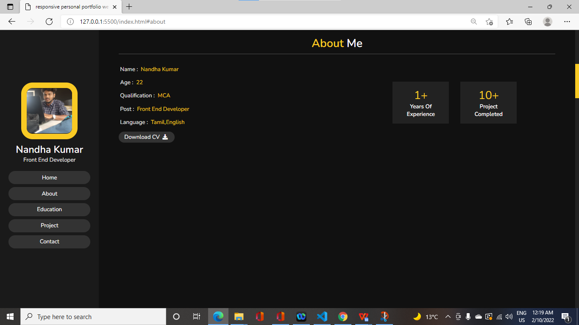
Index.html:

<section class="about" id="about">

<h1 class="heading"> <span>about</span> me </h1>

<div class="row">

<div class="info">
<h3> <span> name : </span> Nandha Kumar</h3>
<h3> <span> age : </span> 22 </h3>
<h3> <span> qualification : </span> MCA </h3>
<h3> <span> post : </span> front end developer </h3>
<h3> <span> language : </span> Tamil,English </h3>
<a href="#"><button class="btn"> download CV <i class="fas fa-download"></i> </button></a>
</div>

<div class="counter">

<div class="box">
<span>1+</span>
<h3>years of experience</h3>
</div>

<div class="box">
<span>10+</span>
<h3>Project Completed</h3>
</div>

</div>

</div>

</section>

Style.css:

.about .row{
display: flex;
align-items: center;
justify-content: center;
flex-wrap: wrap;
padding:1rem 0;
}

.about .row .info{
flex:1 1 48rem;
padding:2rem 1rem;
padding-left: 6rem;
}

.about .row .info h3{
font-size: 2rem;
color:var(--yellow);
padding:1rem 0;
font-weight: normal;
}

.about .row .info h3 span{
color:#eee;
padding:0 .5rem;
}

.about .row .counter{
flex:1 1 48rem;
display: flex;
justify-content: center;
flex-wrap: wrap;
}

.about .row .counter .box{
width:20rem;
background:#222;
text-align: center;
padding: 2rem;
margin:2rem;
}

.about .row .counter .box span{
font-size: 4rem;
color:var(--yellow);
}

.about .row .counter .box h3{
font-size: 2rem;
color:#fff;
}

EDUCATION SECTION:

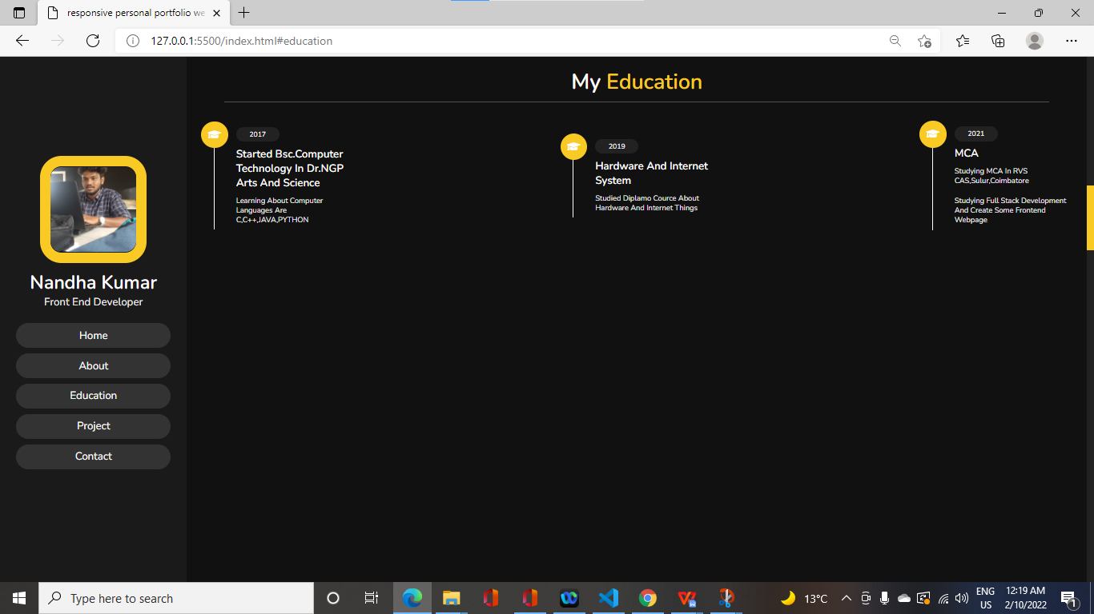

Index.html:

<section class="education" id="education">

<h1 class="heading"> My <span>Education</span> </h1>

<div class="box-container">

<div class="box">
<i class="fas fa-graduation-cap"></i>
<span>2017</span>
<h3>Started Bsc.Computer Technology in Dr.NGP Arts and Science</h3>
<p>Learning about computer languages are C,C++,JAVA,PYTHON</p>
</div>

<div class="box">
<i class="fas fa-graduation-cap"></i>
<span>2019</span>
<h3>Hardware and Internet System</h3>
<p>Studied Diplamo cource about Hardware and Internet things</p>
</div>

<div class="box">
<i class="fas fa-graduation-cap"></i>
<span>2021</span>
<h3>MCA</h3>
<p>Studying MCA in RVS CAS,Sulur,Coimbatore</p>
<p>Studying Full Stack Development and create some Frontend Webpage </p>
</div>

</div>

</section>

Style.css:

.education .box-container{
display: flex;
align-items: center;
justify-content: space-between;
flex-wrap: wrap;
padding:1rem 0;
padding-left: 3rem;
}

.education .box-container .box{
width:27rem;
margin:4rem 1rem;
padding-left: 4rem;
border-left: .2rem solid #fff;
position: relative;
}

.education .box-container .box span{
font-size: 1.3rem;
background:#222;
color:#fff;
border-radius: 5rem;
padding: .5rem 2.5rem;
}

.education .box-container .box h3{
font-size: 2rem;
color:#fff;
padding-top: 1.5rem;
}

.education .box-container .box p{
font-size: 1.4rem;
color:#eee;
padding: 1rem 0;
}

.education .box-container .box i{
position: absolute;
top:-1.5rem; left:-2.5rem;
height:5rem;
width: 5rem;
border-radius: 50%;
line-height: 5rem;
text-align: center;
font-size: 2rem;
color:#fff;
background:var(--yellow);
}

PROJECT SECTION:
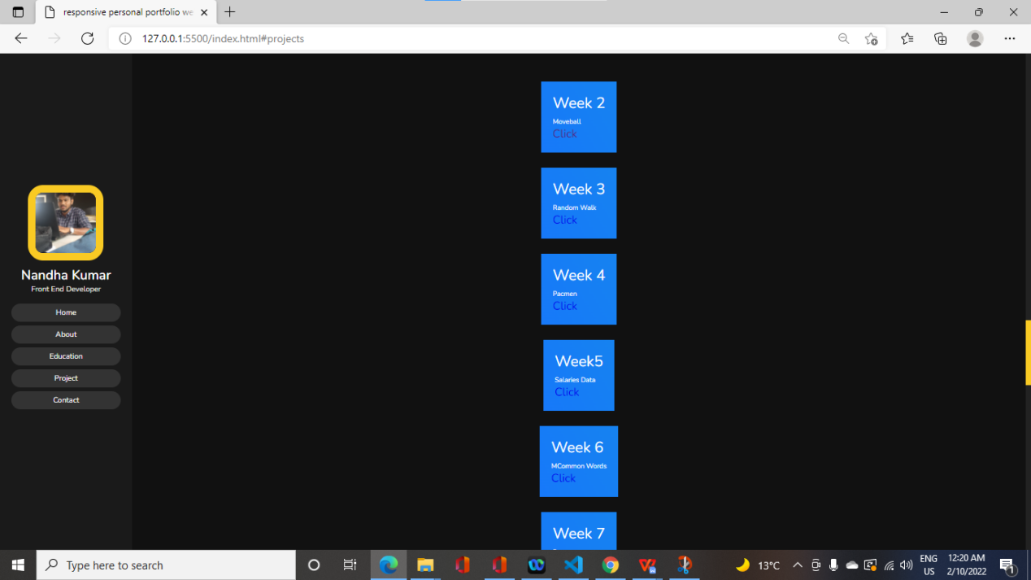
Index.html:

<section class="project" id="project">

<h1 class="heading"> My <span>Project</span> </h1>

<div class="box-container">
<a href="#projects" type="button" class="cta">Learn more</a>
</div>
</div>
</section>
</div>
</div>
</section>
<section id="projects">
<div class="projects container">
<div class="projects-header">
<h1 class="section-title">My <span>Projects</span></h1>
</div>
<div class="all-projects">
<div class="project-item">
<div class="project-info">
<h1>Week 2</h1>
<h2>Moveball</h2>
<p><a href="https://github.com/NANDHAKUMARMCA/week2">click</a></p>
</div>

</div>
<div class="project-item">
<div class="project-info">
<h1>Week 3</h1>
<h2>Random Walk</h2>
<p><a href="https://github.com/NANDHAKUMARMCA/week-3">click</a></p>
</div>

</div>
<div class="project-item">
<div class="project-info">
<h1>Week 4</h1>
<h2>Pacmen</h2>
<p><a href="https://github.com/NANDHAKUMARMCA/week4">click</a></p>
</div>

</div>
<div class="project-item">
<div class="project-info">
<h1>Week5</h1>
<h2>Salaries data</h2>
<p><a href="https://github.com/NANDHAKUMARMCA/week5">click</a></p>
</div>

</div>
<div class="project-item">
<div class="project-info">
<h1>Week 6</h1>
<h2>mCommon words</h2>
<p><a href="https://github.com/NANDHAKUMARMCA/week6">click</a></p>
</div>

</div>
<div class="project-item">
<div class="project-info">
<h1>Week 7</h1>
<h2>Pacman</h2>
<p><a href="https://github.com/NANDHAKUMARMCA/week7">click</a></p>
</div>

</div>
<div class="project-item">
<div class="project-info">
<h1>Week 8</h1>
<h2>Eye movement</h2>
<p><a href="https://github.com/NANDHAKUMARMCA/week-8">click</a></p>
</div>

</div>

<div class="project-item">
<div class="project-info">
<h1>Week 9</h1>
<h2>Map marker</h2>
<p><a href="https://github.com/NANDHAKUMARMCA/week-9">click</a></p>
</div>

</div>
</div>
</div>
</section>

Style.css:

#projects .projects {
flex-direction: column;
max-width: 1200px;
margin: 0 auto;
padding: 100px 0;
}
#projects .projects-header h1 {
margin-bottom: 50px;
}
#projects .all-projects {
display: flex;
align-items: center;
justify-content: center;
flex-direction: column;
}
#projects .project-item {
display: flex;
align-items: center;
justify-content: center;
flex-direction: column;
width: 80%;
margin: 20px auto;
overflow: hidden;
border-radius: 10px;
}
#projects .project-info {
padding: 30px;
flex-basis: 50%;
height: 100%;
display: flex;
align-items: flex-start;
justify-content: center;
flex-direction: column;
background-image: linear-gradient(60deg, #1779fa 0%, #1683f0 100%);
color: white;
}
#projects .project-info h1 {
font-size: 4rem;
font-weight: 500;
}
#projects .project-info h2 {
font-size: 1.8rem;
font-weight: 500;
margin-top: 10px;
}
#projects .project-info p {
font-size: 3rem;
color: aliceblue;
/* font-size: 30px; */

}

.project .box-container{
display: flex;
align-items: center;
justify-content: center;
flex-wrap: wrap;
padding:2rem 0;
}

CONTACT SECTION:
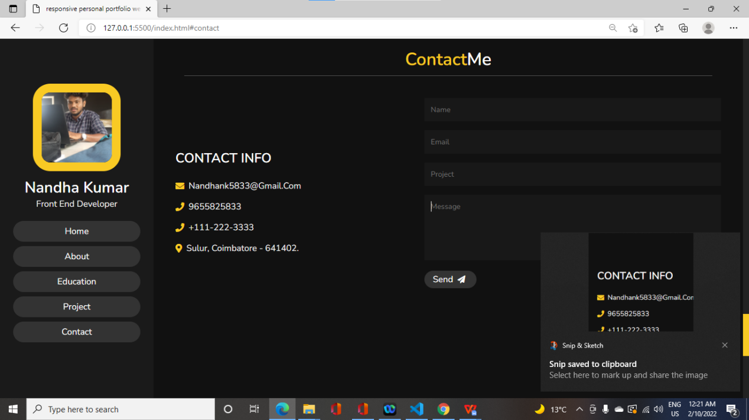
Index.html:

<section class="contact" id="contact">

<h1 class="heading"> <span>Contact</span>Me </h1>

<div class="row">

<div class="content">

<h3 class="title">contact info</h3>

<div class="info">
<h3> <i class="fas fa-envelope"></i> nandhank5833@gmail.com </h3>
<h3> <i class="fas fa-phone"></i> 9655825833 </h3>
<h3> <i class="fas fa-phone"></i> +111-222-3333 </h3>
<h3> <i class="fas fa-map-marker-alt"></i> Sulur, Coimbatore - 641402. </h3>
</div>

</div>

<form action="">

<input type="text" placeholder="name" class="box">
<input type="email" placeholder="email" class="box">
<input type="text" placeholder="project" class="box">
<textarea name="" id="" cols="30" rows="10" class="box message" placeholder="message"></textarea>
<button type="submit" class="btn"> send <i class="fas fa-paper-plane"></i> </button>

</form>

</div>

</section>

Style.css:

.contact .row{
display: flex;
align-items: center;
justify-content: center;
flex-wrap: wrap;
}

.contact .row .content{
flex:1 1 30rem;
padding:4rem;
padding-bottom: 0;
}

.contact .row form{
flex:1 1 45rem;
padding:2rem;
margin:2rem;
margin-bottom: 4rem;
}

.contact .row form .box{
padding:1.5rem;
margin:1rem 0;
background:#3333;
color:#fff;
text-transform: none;
font-size: 1.7rem;
width:100%;
}

.contact .row form .box::placeholder{
text-transform: capitalize;
}

.contact .row form .message{
height: 15rem;
resize: none;
}

.contact .row .content .title{
text-transform: uppercase;
color:#fff;
font-size: 3rem;
padding-bottom: 2rem;
}

.contact .row .content .info h3{
display: flex;
align-items: center;
font-size: 2rem;
color:#eee;
padding:1rem 0;
font-weight: normal;
}

.contact .row .content .info h3 i{
padding-right: 1rem;
color:var(--yellow);
}

Script.js:

$(document).ready(function(){

$('#menu').click(function(){
$(this).toggleClass('fa-times');
$('header').toggleClass('toggle');
});

$(window).on('scroll load',function(){

$('#menu').removeClass('fa-times');
$('header').removeClass('toggle');

if($(window).scrollTop() > 0){
$('.top').show();
}else{
$('.top').hide();
}

});

// smooth scrolling

$('a[href*="#"]').on('click',function(e){

e.preventDefault();

$('html, body').animate({

scrollTop : $($(this).attr('href')).offset().top,

},
500,
'linear'
);

});

});

GITHUB LINKS:
1."https://github.com/NANDHAKUMARMCA/week2"

2."https://github.com/NANDHAKUMARMCA/week-3"

3."https://github.com/NANDHAKUMARMCA/week4"

4."https://github.com/NANDHAKUMARMCA/week5"

5."https://github.com/NANDHAKUMARMCA/week6"

6."https://github.com/NANDHAKUMARMCA/week7"

7."https://github.com/NANDHAKUMARMCA/week-8"

8."https://github.com/NANDHAKUMARMCA/week-9"

PROJECT README:
Project-Readme:

Project1:

Project-2:

Project-3:

Project-4:

Project-5:

Project-6:

Project-7:

Project-8:

Project-9:

